1-Denotation

📘 What is Denotation?
# Source: Chatgpt (GPT-4-turbo) at [7/23/2025]
Denotation is the literal, dictionary definition of a word — the meaning you’d find in a standard reference, without emotion or interpretation. It’s the opposite of connotation, which is the word’s emotional or cultural meaning.

🧠 Key Points:
# Source: Chatgpt (GPT-4-turbo) at [7/23/2025]
- Denotation = direct meaning
- It’s objective and factual, not influenced by feelings or context.
- It stays the same regardless of how a word is used emotionally or socially.

🔍 Examples of Denotation:
# Source: Chatgpt (GPT-4-turbo) at [7/23/2025]
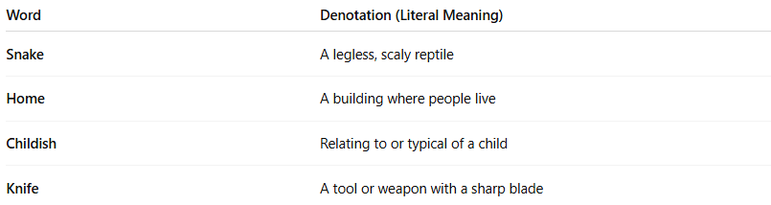

Word | Denotation (Literal Meaning)
Snake | A legless, scaly reptile
Home | A building where people live
Childish | Relating to or typical of a child
Knife | A tool or weapon with a sharp blade

🔁 Denotation vs. Connotation:
# Source: Chatgpt (GPT-4-turbo) at [7/23/2025]
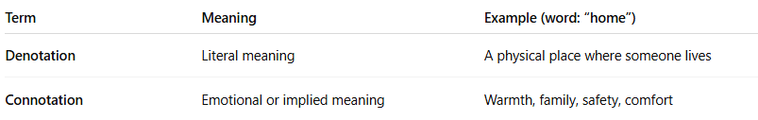
Term | Meaning | Example (word: “home”)
Denotation | Literal meaning | A physical place where someone lives
Connotation | Emotional or implied meaning | Warmth, family, safety, comfort

✅ Summary:
# Source: Chatgpt (GPT-4-turbo) at [7/23/2025]
Denotation is a word’s exact, dictionary meaning, without any added feelings or associations.
Understanding both denotation and connotation is essential in literature, advertising, and everyday communication, especially to avoid misunderstandings or to create precise tone.

2-Connotation

🌟 What is Connotation?
# Source: Chatgpt (GPT-4-turbo) at [7/23/2025]
Connotation is the emotional, cultural, or implied meaning of a word — beyond its dictionary (literal) definition. It includes the feelings, associations, or ideas that a word brings to mind.

📘 Definition:
# Source: Chatgpt (GPT-4-turbo) at [7/23/2025]
Connotation is the suggested or implied meaning of a word, in addition to its denotation (literal or dictionary meaning).

🧠 Key Points:
# Source: Chatgpt (GPT-4-turbo) at [7/23/2025]
- Words can have positive, negative, or neutral connotations.
- The connotation of a word may change depending on context, culture, or tone.
- Understanding connotation helps avoid misunderstanding or offending someone unintentionally.

🔍 Examples of Connotation:
# Source: Chatgpt (GPT-4-turbo) at [7/23/2025]
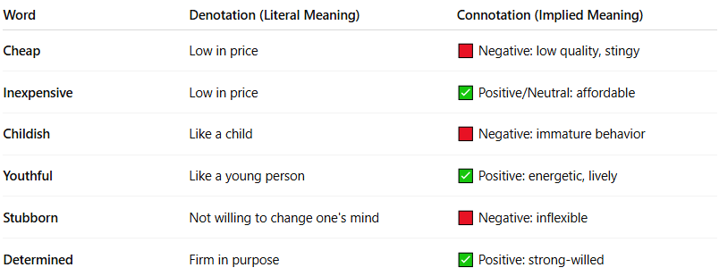
Word | Denotation (Literal Meaning) | Connotation (Implied Meaning)
Cheap | Low in price | 🟥 Negative: low quality, stingy
Inexpensive | Low in price | ✅ Positive/Neutral: affordable
Childish | Like a child | 🟥 Negative: immature behavior
Youthful | Like a young person | ✅ Positive: energetic, lively
Stubborn | Not willing to change one's mind | 🟥 Negative: inflexible
Determined | Firm in purpose | ✅ Positive: strong-willed

🧾 Connotation vs Denotation:
# Source: Chatgpt (GPT-4-turbo) at [7/23/2025]
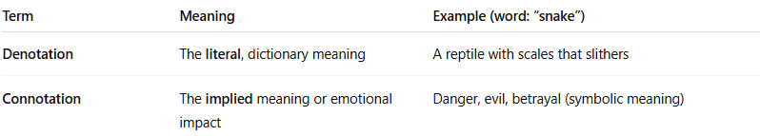
Term | Meaning | Example (word: “snake”)
Denotation | The literal, dictionary meaning | A reptile with scales that slithers
Connotation | The implied meaning or emotional impact | Danger, evil, betrayal (symbolic meaning)

✅ Summary:
# Source: Chatgpt (GPT-4-turbo) at [7/23/2025]
Connotation is the emotional or cultural "baggage" a word carries — what it suggests or feels like, not just what it literally means.

3-Collocation

🔗 What is a Collocation?
# Source: Chatgpt (GPT-4-turbo) at [7/23/2025]
A collocation is a natural combination of words that are often used together by native speakers. These word pairings “sound right” to fluent speakers, even if there’s no grammar rule that explains them. They are an important part of sounding natural and fluent in any language.

📘 Definition:
# Source: Chatgpt (GPT-4-turbo) at [7/23/2025]
A collocation is a group of two or more words that are commonly used together in a way that sounds natural to native speakers.

🧠 Key Points:
# Source: Chatgpt (GPT-4-turbo) at [7/23/2025]
- Not just random combinations — they are statistically frequent and culturally expected.
- Help avoid awkward or unnatural phrasing.
- Collocations are often memorized like chunks, not invented word-by-word.

🔍 Examples of Collocations:
# Source: Chatgpt (GPT-4-turbo) at [7/23/2025]
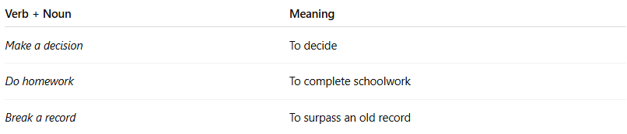
Verb + Noun | Meaning
Make a decision | To decide
Do homework | To complete schoolwork
Break a record | To surpass an old record

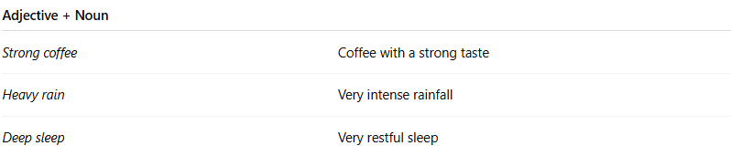
Adjective + Noun
Strong coffee | Coffee with a strong taste
Heavy rain | Very intense rainfall
Deep sleep | Very restful sleep

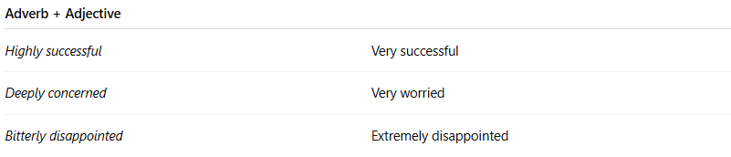

Adverb + Adjective
Highly successful | Very successful
Deeply concerned | Very worried
Bitterly disappointed | Extremely disappointed

❌ Unnatural vs. ✅ Natural:
# Source: Chatgpt (GPT-4-turbo) at [7/23/2025]
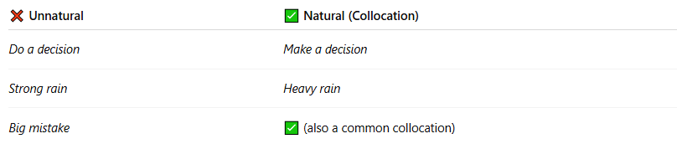
❌ Unnatural | ✅ Natural (Collocation)
Do a decision | Make a decision
Strong rain | Heavy rain
Big mistake | ✅ (also a common collocation)

📚 Types of Collocations:
# Source: Chatgpt (GPT-4-turbo) at [7/23/2025]
- Verb + Noun → make money, catch a cold
- Noun + Noun → a round of applause, a surge of anger
- Adjective + Noun → strong wind, hard worker
- Verb + Adverb → apologize sincerely, whisper quietly
- Adverb + Adjective → deeply sorry, completely wrong

✅ Summary:
# Source: Chatgpt (GPT-4-turbo) at [7/23/2025]
A collocation is a pair or group of words that naturally go together in a language. Learning them helps you sound more fluent and accurate in speaking and writing.

